Dis-Gudea-Statue

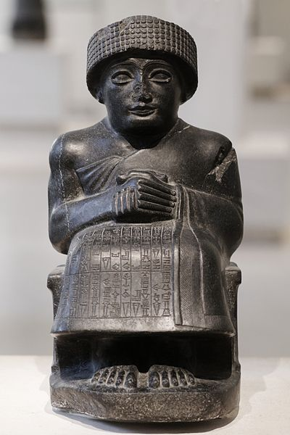

|  |
| --- |
| Seated diorite statue of [Gudea, prince of Lagash](https://commons.wikimedia.org/wiki/Gudea), dedicated to the god Ningishzida, [neo-Sumerian](https://commons.wikimedia.org/wiki/Sumer) period. |
| Object type | [Statue](https://en.wikipedia.org/wiki/Statue) |
| Date | circa 2120 [BC](https://en.wikipedia.org/wiki/Ante_Christum_Natum) |
| Medium | diorite |
| Dimensions | Height: 46 cm (18.1 in). Width: 33 cm (13 in). Depth: 22.5 cm (8.9 in). |
| Current location | |  | | --- | | **(**[**Inventory**](https://commons.wikimedia.org/wiki/Mus%C3%A9e_du_Louvre:Inventory)**)**[**Louvre Museum**](https://en.wikipedia.org/wiki/Mus%C3%A9e_du_Louvre)**[Link back to Institution infobox template](https://commons.wikimedia.org/wiki/Institution:Louvre) [wikidata:Q19675](https://www.wikidata.org/wiki/Q19675)** | |
| Mésopotamie, [room 2: Mésopotamie, 2350 à 2000 avant J.-C. environ](https://commons.wikimedia.org/wiki/Category:Near_Eastern_Antiquities_in_the_Louvre_-_Room_2). Richelieu, ground floor. This work is part of the collections of the Louvre (Department of Near Eastern Antiquities). |
| Accession number | [AO](https://commons.wikimedia.org/wiki/Category:Mus%C3%A9e_du_Louvre:Inventory/AO) 3293 [Info non-talk.svg](https://commons.wikimedia.org/wiki/Commons:Louvre/accession_number)(head) &[AO](https://commons.wikimedia.org/wiki/Category:Mus%C3%A9e_du_Louvre:Inventory/AO) 4108 [Info non-talk.svg](https://commons.wikimedia.org/wiki/Commons:Louvre/accession_number)(body) |
| Object history | From Telloh (ancient Girsu), [Iraq](https://commons.wikimedia.org/wiki/Iraq). Head excavated by Ernest de Sarzec; body excavated by Gaston Cros excavations, 1903 |
| References | Musée du Louvre, [Atlas database](https://fr.wikipedia.org/wiki/Base_Atlas): entry [11975](http://cartelen.louvre.fr/cartelen/visite?srv=car_not_frame&idNotice=11975) |